Press 1 to give control of camera

Press 2 to move camera along set path

https://youtu.be/OHDRQ2D_iJ4

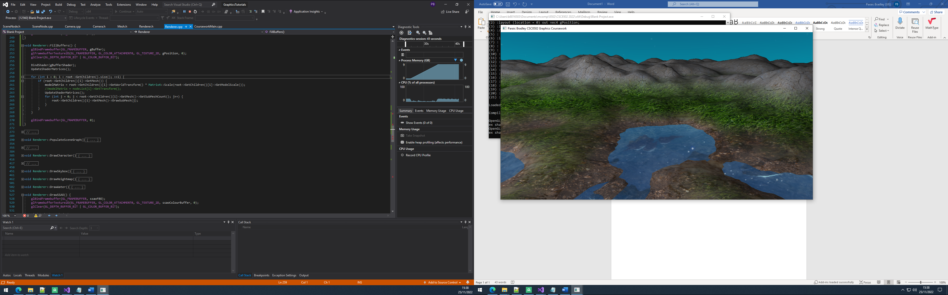

Multiple blended textures on heightmap

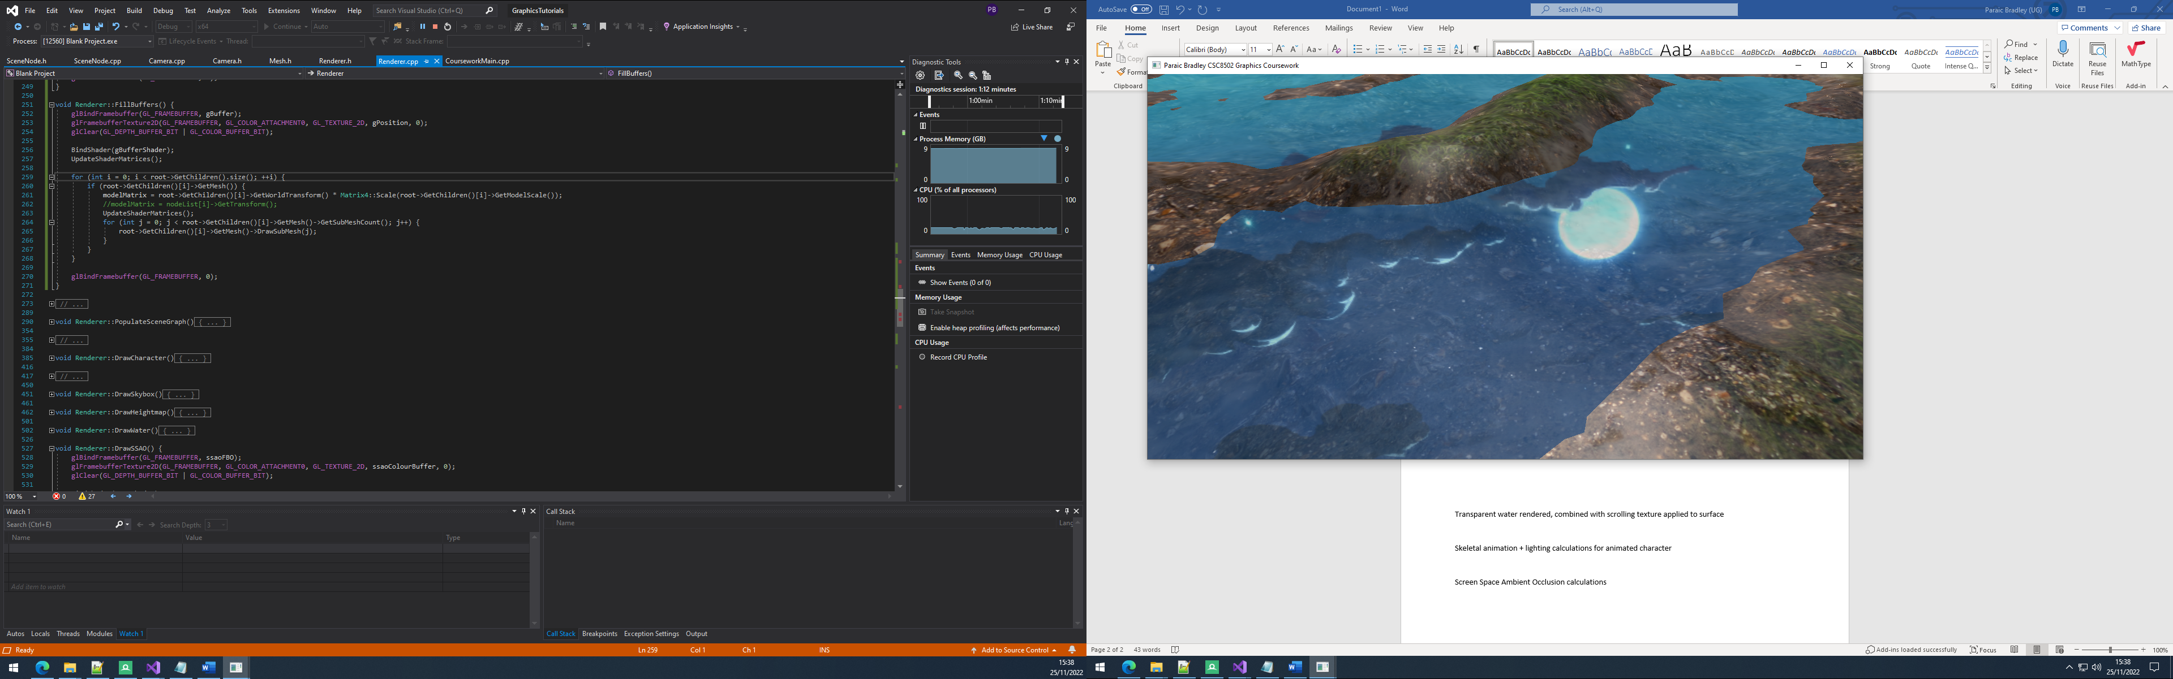

Transparent water rendered, combined with scrolling texture applied to surface

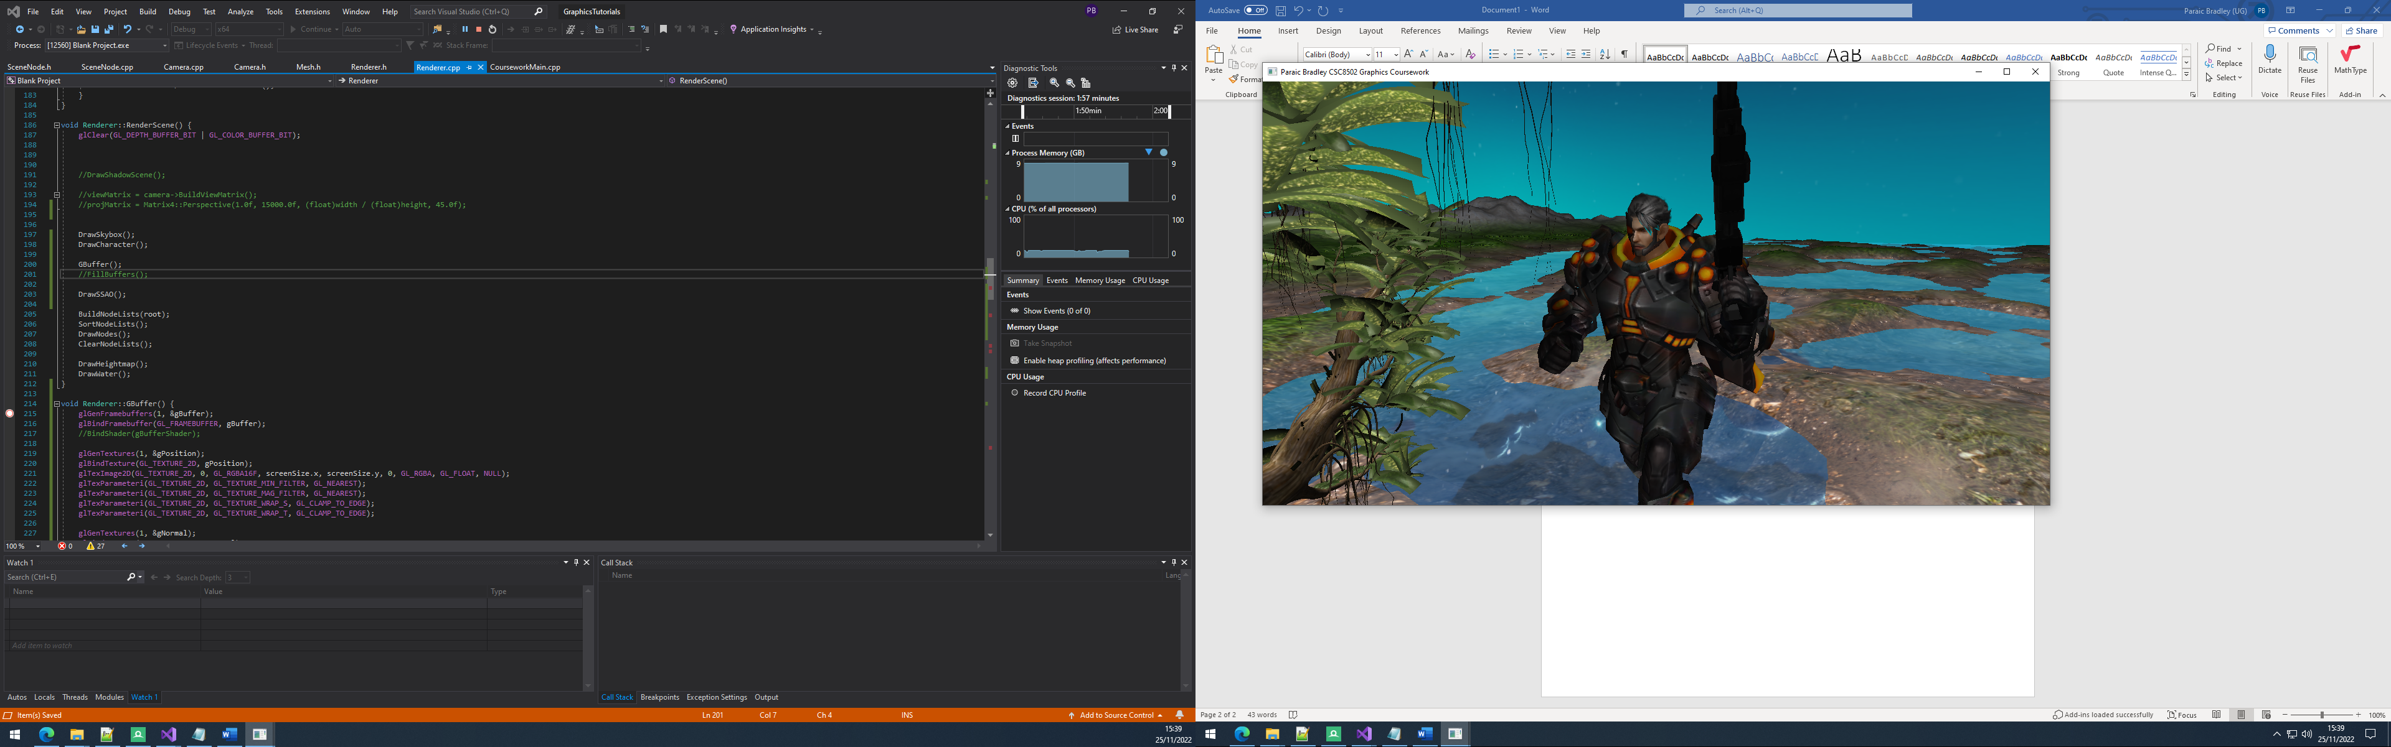

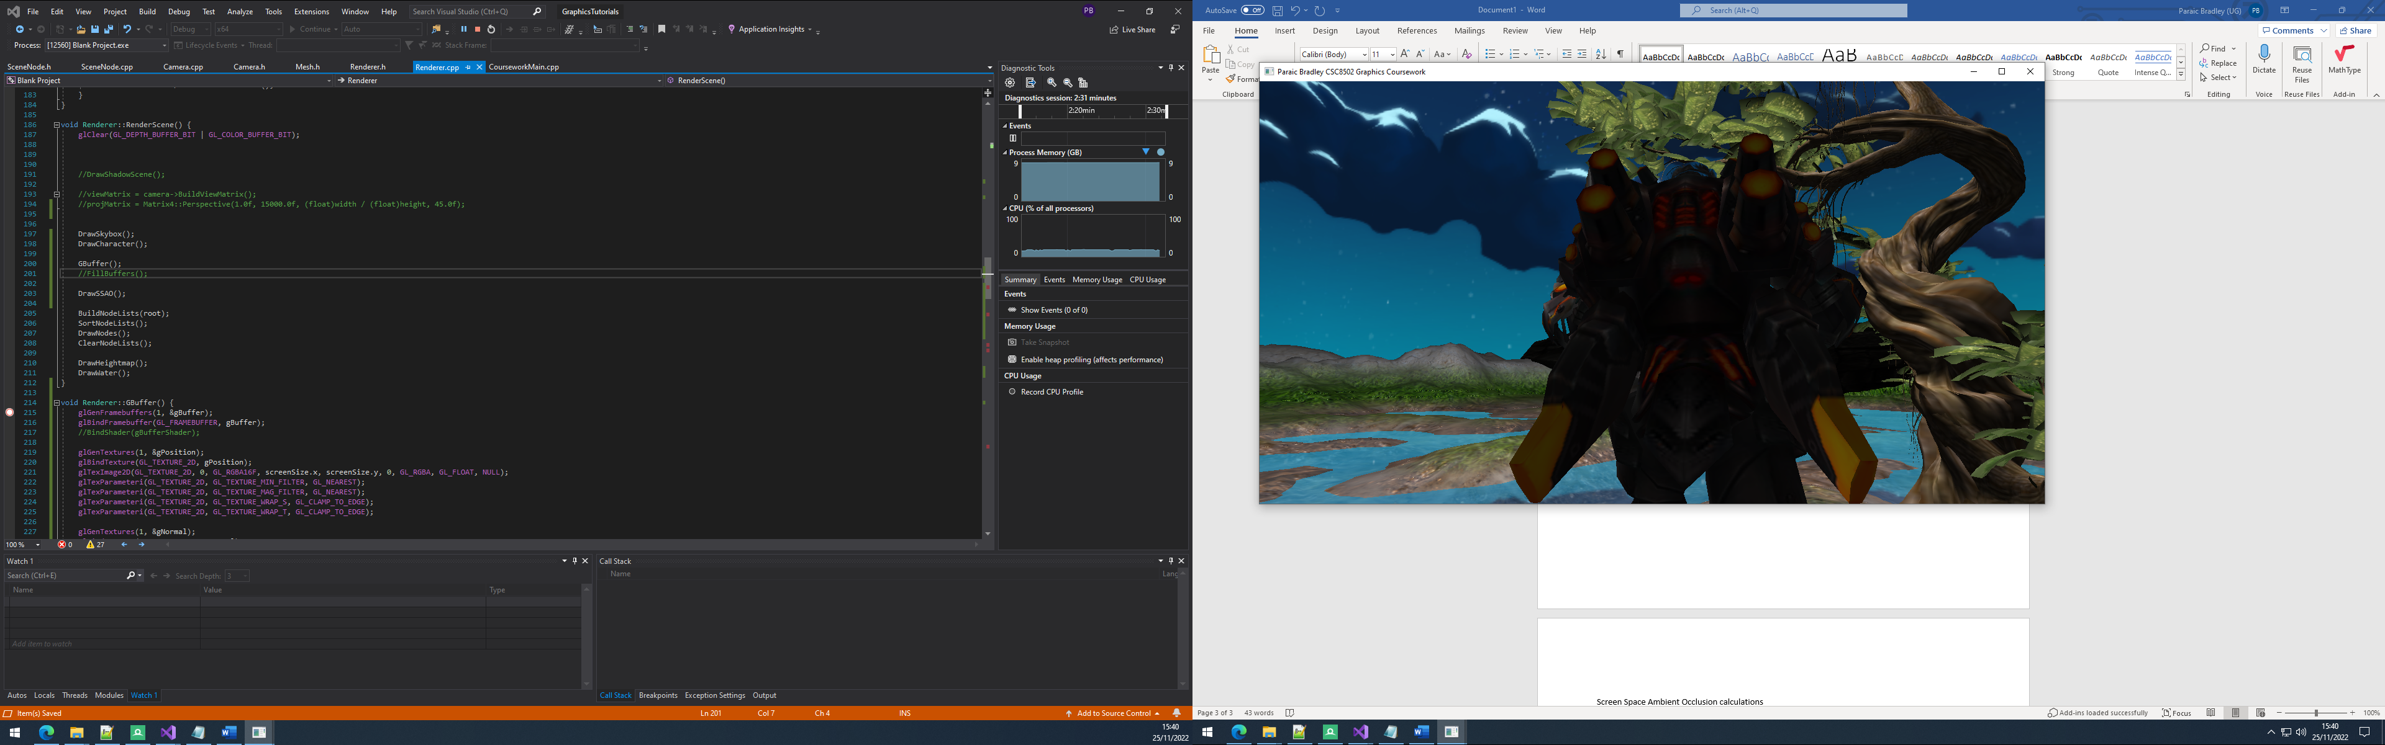

Skeletal animation + lighting calculations for animated character

Screen Space Ambient Occlusion calculations attempted, mostly complete but not working due to issues with g buffer

SSAO code modified from the following tutorial:

<https://learnopengl.com/Advanced-Lighting/SSAO>

Tree models from:

<https://www.turbosquid.com/3d-models/3d-6-trees-collection-1750898>

Rock model from Unity Store